SPRINT-2

Project Title: Personal Assistance for Seniors Who Are Self Reliant.

Team ID: PNT2022TMID14299

Created a Node-RED service to IBM Cloud

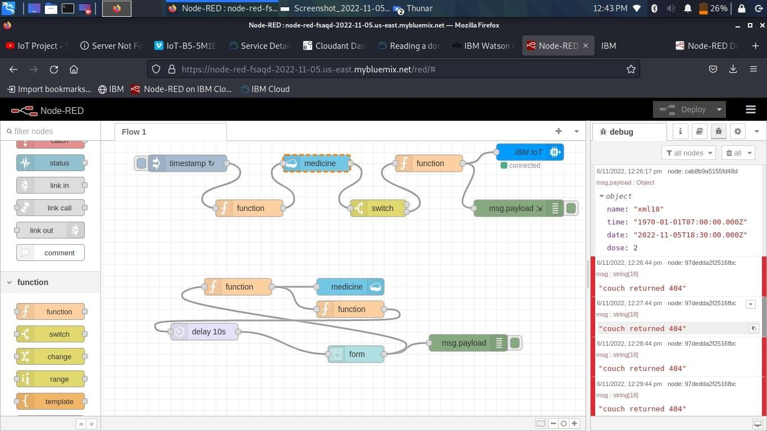

Created a form for taking the user inputs like medicine name, time, and date:

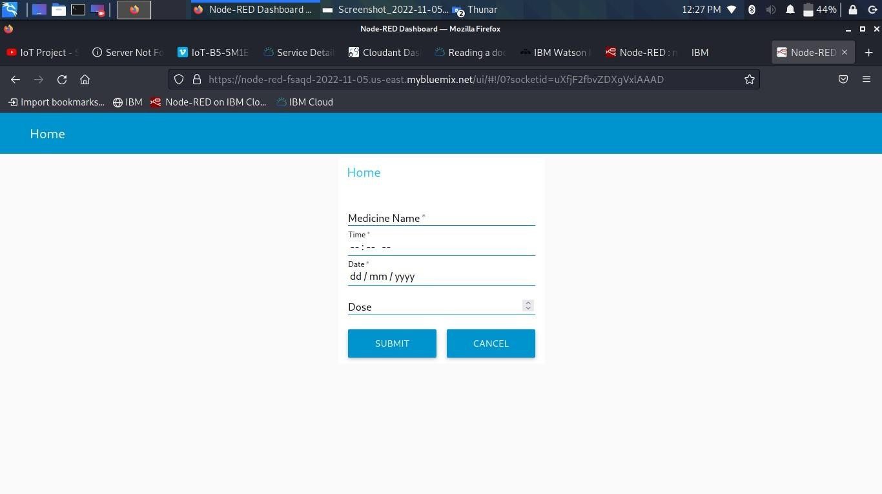

Created a database to store the medicine details

Jira process:

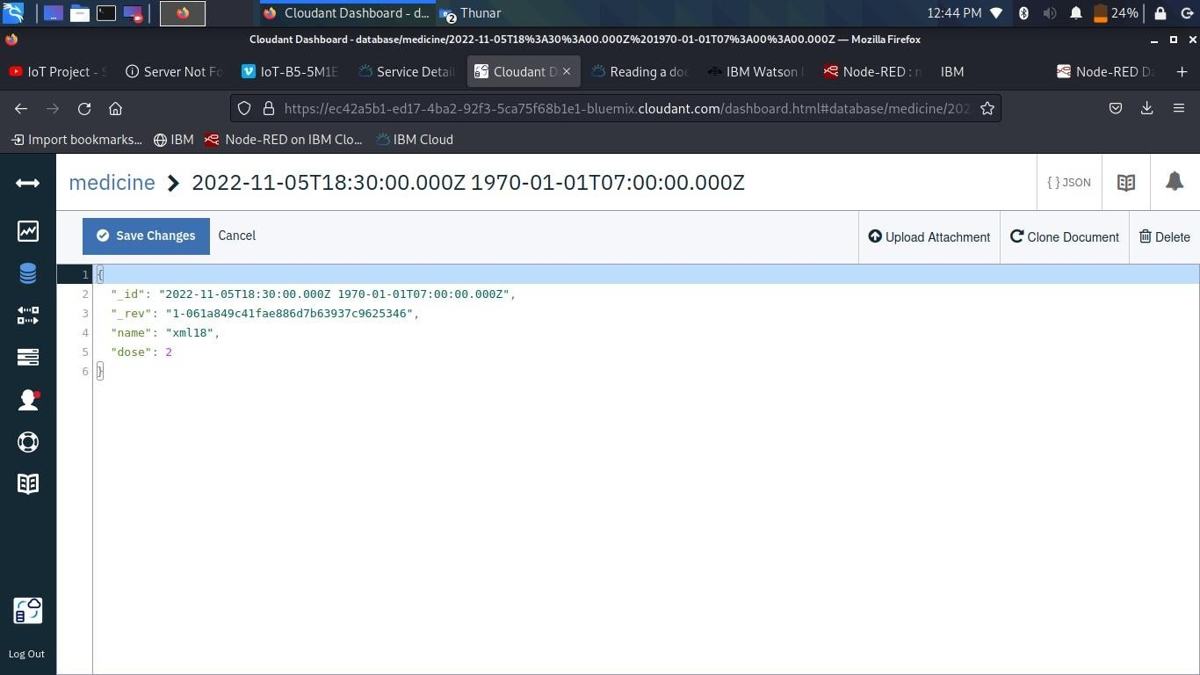

Jira process:

